Hi Sunny –

The new modifications from yesterday all look great. Thanks again for implementing everything so quickly!

I’m wondering if we can also make the following enhancements to the charts:

1 – Main CSI chart

Can we change the names in the legend from “CSI1” and “CSI2” → “CSI” and “CSI Lag” ?

Can we combine both the standard deviation buttons in the legend and name the new consolidated label as “CSI Standard Deviations” ?

Finally, can Volatility Forecast as a graphed data series please be removed from the chart? (I plan on using it for a future chart, but I think eliminating it here is a good idea to simplify the amount of information plotted on this one)

2 – Pie Chart

Can the pattern from the pie chart please be removed? (so the slices will just be solid colors)

3 – Gauges

Question – is the text in gauges set to adapt to different screen resolutions? (i.e., does it use responsive logic like the text in the fat tails and option accuracy charts?)

New chart #1 – Two horizontal bar charts

Can we create new horizontal bar charts? Where one will be for Volatility and the second will be for Sharpe Ratio? These will follow the same color scheme formatting as everything else and resemble the horizontal bar chart for PnL (screenshot below)

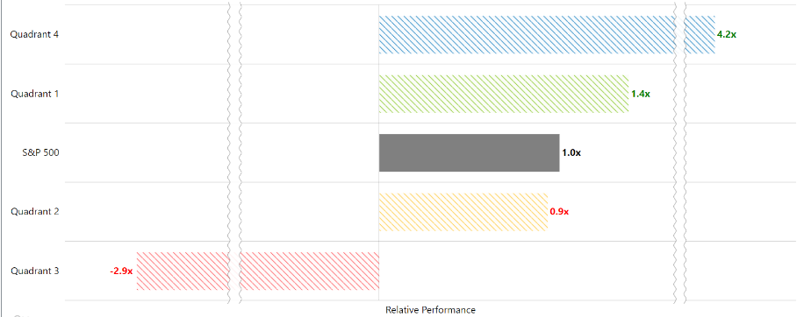

Let’s not include any breaks in the graph until seeing how the graphs look without them. Perhaps if one of the bars is dominating the graph too much, we’ll add a break.

New chart #2 – Connected horizontal bar chart

This description will be geared towards the new treemap (which looks really great btw!). There are actually a few things to discuss about the treemap:

1 – I created a pythonanywhere table and uploaded the data to be graphed into it. The name of the new table is “treemap”. Additionally, I added two more data series to be plotted on the treemap. The updated name of the categories are:

S&P 500  
Russell 2000  
Commodities  
Emerging Markets  
20+ yr Treasuries  
Gold  
Real Estate

2 – Stripes to squares that are negative values

I don’t know if this is possible… but for squares that are negative values (e.g., 20+ yr Treasuries in Quadrant 1, S&P 500 in Quadrant 3, etc.), can there be a pattern applied to the individual square? For example, what I have in mind would look something similar to the below:

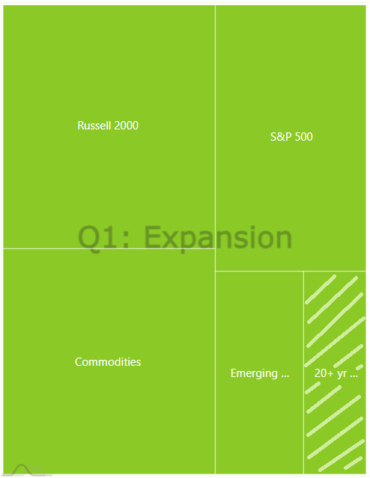

3 – I would like to try creating a second chart that changes based on where on the treemap a user clicks. For example, amcharts allows for charts to be anchored together: <https://www.amcharts.com/demos/hybrid-drill-down-pie-bar-chart/>

The second chart will be a horizontal bar chart placed just under the treemap. The behavior I’m hoping to achieve is the following: Whenever someone clicks on a square, the data graphed on the horizontal bar chart will be that asset’s performance in each of the four CSI quadrants. For example, if someone click’s “20+ yr Treasuries”, then the horizontal bar chart will graph each of the four values shown in the tooltip display for each quadrant. In this case, if someone clicked 20+ yr Treasuries, the values would be: Quadrant 1: -15.13%, Quadrant 2: -4.4%, Quadrant 3: 33.56%, Quadrant 4: 4.85%.